**Tech Saksham**

Case Study Report

Data Analytics with Power BI

**Real-Time Analysis of Bank**

**Customers**

***Government Arts College, Krishnagiri 635001***

|  |  |
| --- | --- |
| NM ID | NAME |
| 2AED4B05D2D0AE584BE458CB4D9F5E15 | PRAVEENKUMAR R |

Trainer Name : R UMAMAHESWAEI Master Name : R UMAMAHESWARI

INDEX

|  |  |  |
| --- | --- | --- |
| Sr. No | Table of Contents | Page No. |
| 1 | Chapter 1: Introduction | 4 |
| 2 | Chapter 2: Services and Tools Required | 6 |
| 3 | Chapter 3: Project Architecture | 7 |
| 4 | Chapter 4: Modeling and Result | 8 |
| 5 | Conclusion | 9 |
| 6 | Future Scope | 9 |

CHAPTER 1

**INTRODUCTION**

1.1 Problem Statement

In many various sectors have problem with the efficiency of a customer behavior, preferences. This will play a major role in Banking Sector. However, this problem creating a crucial effect of banking history. Traditional data analysis has a problem with this trend which is rapidly changing, time consuming and lack to provide insightful solution.

1.2 Proposed Solution

The proposed solution is taking a most advanced Software’s to create insightful real-time analytics. In this project we using a one of powerful Analytical tool called Power BI. We have to real-time dashboard of a bank customers data with Power BI. Using this tool, we can analyze the data for customer preferences and tailoring the User Experience for the customers.

1.3 Feature

* Real-Time Analysis: The dashboard will provide a real-time analysis of customer data
* Customer Segmentation: It will segment customers based on various parameters like age, gender, behavior, etc.
* Predictive Analysis: It will use previous data to forecast the customer behavior.
* Trend Analysis: The dashboard will display the trends of customer behavior.

1.4 Advantages

* Data-Driven Decisions: Banks can make insightful decisions with realtime data.
* Increased Efficiency: From the analytics the we can get the efficiency of handling the customer’s data.
* Increased Revenue: By Identifying the flaws, we can grow the trust of customers and increasing the revenue.

1.5 Scope

* The Scope of the project is widely used for all sector other than banking.
* This project can be extended for more data resources.
* We can also build stronger analytics with data.

CHAPTER 2

SERVICES AND TOOLS REQUIRED

Tools:

* Power BI: The main tool for this project Power BI, which is use to create interactive dashboards for real-time data visualization.
* Power Query: This is a data connection technology that enables you to discover, connect, combine, and refine data across a wide variety of source.

Software Requirements:

* Power BI Desktop: This is a windows application that you can create reports and publish them to Power BI.
* Power BI Service: This is an Online SaaS (Software as a Service) Service that you use to publish reports, create new dashboards, and share insights.
* Power BI Mobile: This is a mobile application that you can use to access your reports and dashboards on the go.

CHAPTER 3

PROJECT ARCHITECTURE

3.1 Architecture

* Data Collection: Real-time customer data collected from various sources(transactions, web interaction).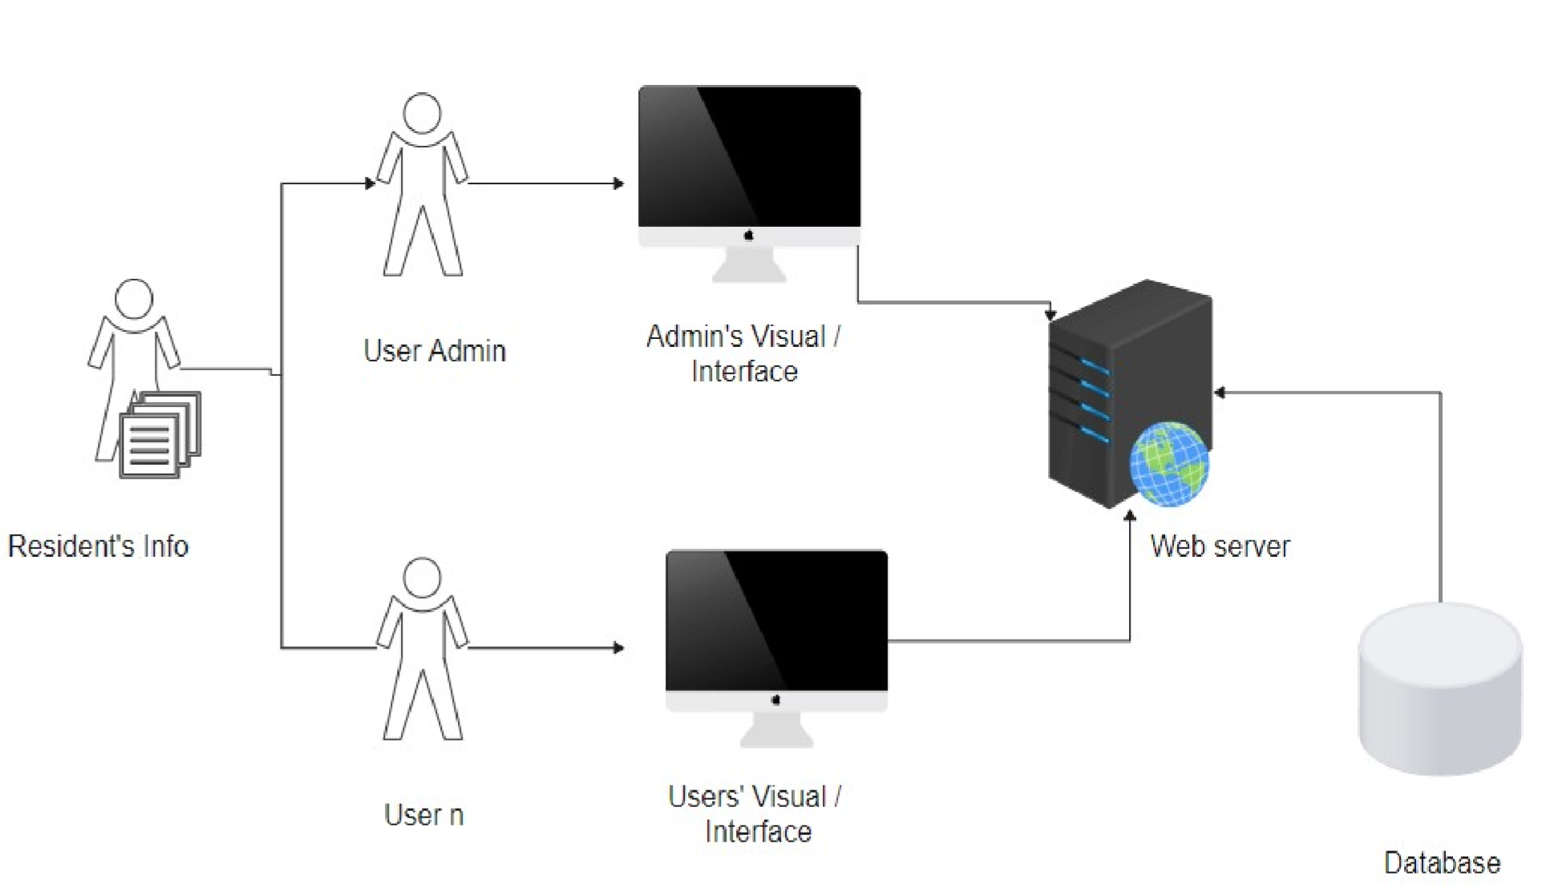
* Data Storage: Collected Data is stored in database and Servers.
* Data Processing: Non sensitive data is processed to take analysis.
* Analytics : Processed Data is analyzed by experts.

CHAPTER 4

MODELING AND RESULT

Manage Relationship

In this Project CSV file with name ‘Real-Time Analysis of Bank Customers’ is added for analytics.

Dashboard

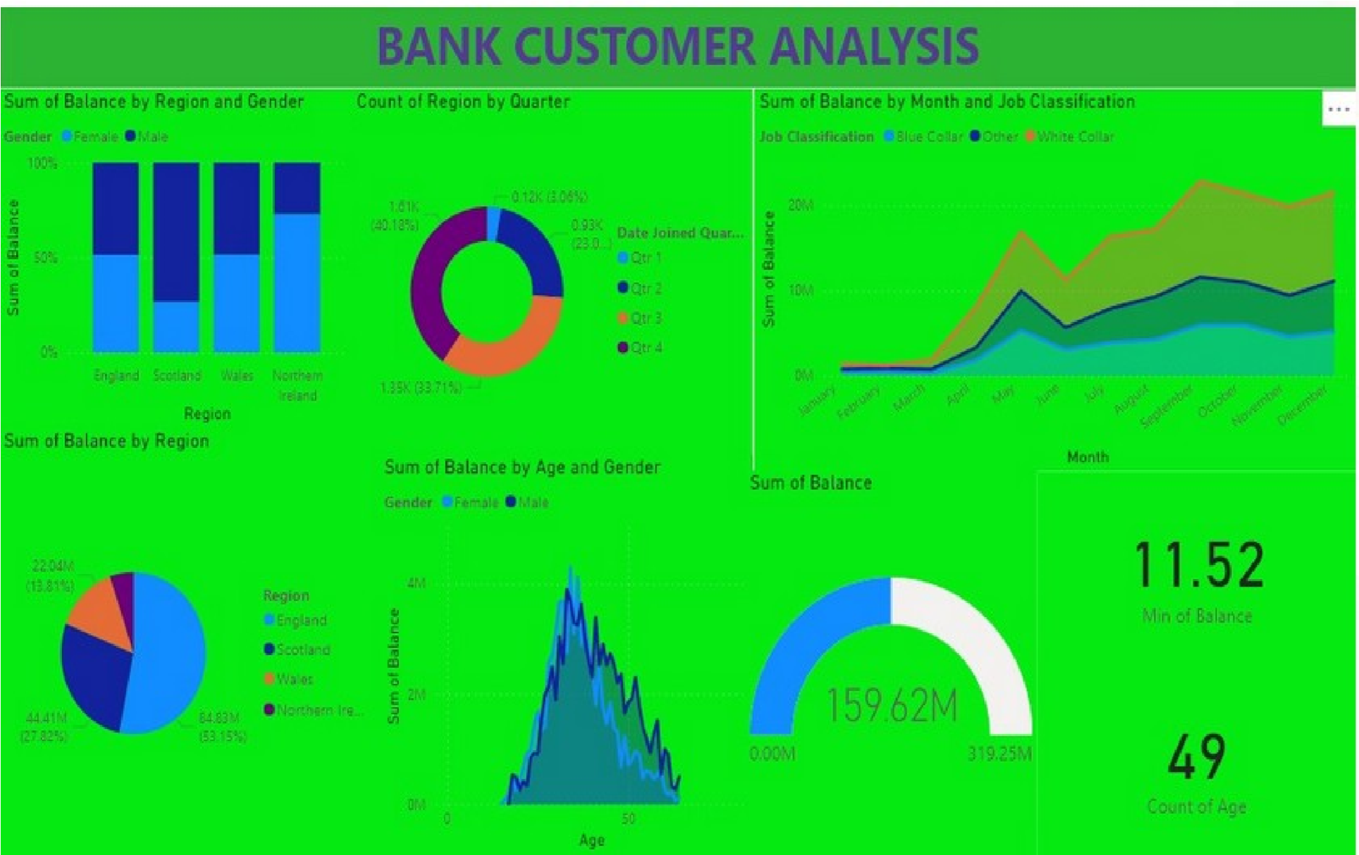

CONCLUSION

From the project “Real-Time analysis of Bank Customers” using Power BI has successfully created and we conclude the major effects of project from our dashboard. The real-time data provided lots of valuable information for our insightful analytics for customer behavior, preferences and we can improve our efficiency on customer’s personalized experience improvement. This project

has enhanced our ability to provide efficient services for customers. The project has highlighted the importance of simplifying the complex data for easy to understand in simple terms. The presented data is easy appealing to understand.

FUTURE SCOPE

The future scope of this project is vast. Using the advanced analytics and machine learning, Power BI can be leveraged to predict future trends based on historical data. As data privacy and security become increasingly important, future iterations of this project should focus on implementing robust data governance strategies. This would ensure the secure handling of sensitive customer data while complying with data protection regulations. The project could explore the integration of real-time data streams to provide even more efficient insights. This could potentially transform the way banks interact with their customers, leading to improved customer satisfaction.